Software Specification and Requirements for Sewer Logic

Version 2 unapproved

Prepared by Brandon Helmericks and Hannah Tsunemori

University of Alaska Anchorage

02/09/2017

Table of Contents..........................................1

1. Introduction...........................................2

1.1 Purpose............................................2

1.2 Document Conventions...............................2

1.3 Intended Audience and Reading Suggestions..........2

1.4 Product Scope......................................2

1.5 References.........................................2

2. Overall Description....................................3

2.1 Product Perspective................................3

2.2 Product Functions..................................3

2.3 User Classes and Characteristics...................3

2.4 Operating Environment..............................4

2.5 Design and Implementation Constraints..............4

2.6 User Documentation.................................4

2.7 Assumptions and Dependencies.......................4

3. External Interface Requirements........................4

3.1 User Interfaces....................................4

3.2 Hardware Interfaces................................5

3.3 Software Interfaces................................5

3.4 Communications Interfaces..........................5

4. System Features........................................5

4.1 Serial Communication and Control...................5

4.2 Data Logging and Modeling..........................6

4.3 Digital Display....................................6

4.4 Streamline Reuse System Software...................7

5. Other Nonfunctional Requirements.......................7

5.1 Performance Requirements...........................7

5.2 Safety Requirements...............................7

5.3 Software Quality Attributes.......................7

5.4 Business Rules....................................8

Appendix A: Glossary......................................8

Appendix B: Analysis Models...............................8

1. Introduction

1.1 Purpose

The Graphical User Interface for the Dotson Lab Alaska Water Sewage Challenge acts as a way

for a homeowner to interact with the Alaska Water Sewage Challenge project that is being

created in Dotson Lab. The User Interface for the Dotson Lab

Alaska Water Sewage Challenge is hereafter referred to as "Interface". The Dotson Lab Alaska

Water Sewage Challenge is hereafter referred to as "reuse system". The Interface will:

(a) Maintain Serial Communication and Control

(b) Data logging and Modeling

(c) Display features

(d) Streamline reuse system software

1.2 Document Conventions

This document assumes there are no other graphical user interfaces used in conjunction with the

reuse system.

At time of writing, this is the singular graphical user interface that will be used for typical

interactions with the reuse system.

1.3 Intended Audience and Reading Suggestions

This document is for the developers and Dotson Lab hereinafter referred to as "the user".

The developers will be able to determine how to meet the requirements from this document.

The user will be able to determine what to expect they can do with this product and how it works

to meet their needs.

The document is organized in the following order: introductory information, product creation,

external interactions, product features, and non-functional requirements.

1.4 Product Scope

The Interface will connect the user to the control and monitoring Arduino Mega in the reuse system.

The Interface will allow a user to view water levels, flow rates, valve positions and operational

status as well as if the reuse system has an issue that needs to be addressed and trigger an alarm.

The Interface will log all data to daily files as clear text. The data logging feature is specifically

designed for research purposes of the user or in further troubleshooting of maintenance company.

It also allows advanced users to manually control the valve positions, stepper motors and

electrical relays.

A schematic of this system can be seen in the SystemSchematic.png figure.

1.5 References

SystemSchematic.png

User Views:

Inserted in Appendix B on printable versions:

AdvancedUserView_MonitoringPowerAndTemperature.png

AdvancedUserView_PressureAndFlow.png

AdvancedUserView_SystemStatus.png

AdvancedUserView_WaterLevels.png

HomeownerView.png

2. Overall Description

2.1 Product Perspective

The Interface is to be used with the reuse system. It is to read information from the Arduino

Mega chip that will control and monitor the system on a hardware level. The interface will be

constructed on a touchscreen interface attached to a Raspberry Pi.

2.2 Product Functions

(a) Maintain Serial Communication and Control

This is needed so that the Interface can present/store data and manually control the system.

(b) Data logging and Modeling

This is a requirement for the user who may have other research uses for previous data.

The data logs will be accessible through an SD card on the Raspberry Pi.

This also will allow data to be presented in a readable format to the reader.

(c) Display features

This will allow users to interact and read the data on the touch screen device.

This will include determining what information to show by selecting a user type.

(d) Streamline reuse software

This will be achieved through consulting for the client as the code on the Arduino Mega the

Interface reads from will be corrected as needed.

2.3 User Classes and Characteristics

There are three classes of users that will use the Interface. These users will be referred to as

"basic user", "advanced user", and "admin user".

Basic User Needs:

(1) Notification of when to empty waste

(2) Notification when, how much, and where water needs to be added to the system

(3) Notification when there is a problem identified including alarm

Advanced User Needs:

(1) All Basic User Needs

(2) Display of all water levels measured in system

(3) Display of all valve positions in system

(4) Display of pressures measured in system

(5) Display of power to components

(6) Display of temperature of control panels and reuse system building

(7) Display of and access to run relays

Admin User Needs:

(1) All Advanced User Needs

(2) Data logging of measured data in text files

(3) Consulting on code written for system

For the purposes of this document the basic user needs are of the highest importance as all other

user needs include those of the basic user.

2.4 Operating Environment

The interface will be running on a Raspberry Pi 3 Model B with a 7" touchscreen display (800x

480 pixels). The Raspberry Pi will be running the Raspbian operating system. The Raspberry Pi

will need to communicate with code written by the user running on the Arduino Mega through a

serial connection.

2.5 Design and Implementation Constraints

Problems include unknown code interactions in working in parallel with reuse system that is still

in design phase.

The Interface must interact with Arduino Mega code written for the reuse system.

The Interface will communicate to the Arduino Mega through the GPIO ports on the Raspberry

Pi.

Data logging will be stored to memory in user provided SD card.

There will be no databases as per client request. Data is to be stored in text files.

User must be able to maintain and modify code as needed.

Client side code will need modification as per request of user (consulting) during implementation

of the Interface.

2.6 User Documentation

Comments in code are required for future maintenance by user.

Readme files for user must also be included.

2.7 Assumptions and Dependencies

It is assumed the Interface development takes priority over consulting hours.

It is assumed data read into the Interface is correct data.

It is assumed the admin user will be able to pull information from the SD card without further

instructions.

It is assumed the basic user will not attempt to use the "Manual" option in the "Advanced User"

tab.

3. External Interface Requirements

3.1 User Interfaces

The primary user interface will be the 7" Raspberry Pi Touchscreen. The dimensions of the

touchscreen are 194mm x 110mm x 20mm (800 x 480 pixels).

Data will be displayed and modeled as can be seen in the User Views Referenced in Section 1.5.

Basic User Needs:

(1) Notification of when to empty waste

(2) Notification when, how much, and where water needs to be added to the system

(3) Notification when there is a problem identified including alarm

Advanced User Needs:

(1) All Basic User Needs

(2) Display of all water levels measured in system

(3) Display of all valve positions in system

(4) Display of pressures measured in system

(5) Display of power to components

(6) Display of temperature of control panels and reuse system building

(7) Display of and access to electrical relays

3.2 Hardware Interfaces

Serial connection between the Arduino Mega and Raspberry Pi (GPIO) used to send

data/commands. Preferred code language is Python for user readability. The GUI for the

interface will be displayed on a 7" touchscreen display connected to the Raspberry Pi via a DSI ribbon cable.

3.3 Software Interfaces

This section cannot be fully defined until approximately 2/24/17 when the Arduino Mega is

programmed.

Questions to answer in this section include:

The Interface will be receiving information pushed from the Arduino Mega at set intervals.

The Interface will also be sending information back to the Arduino Mega in the form of controls.

The data will be stored in text documents and processed using Python.

3.4 Communications Interfaces

The communications to and from the Arduino Mega will be through GPIO.

4. System Features

4.1 Serial Communication and Control

4.1.1 Description and Priority

The serial communication allows the interface running on the Raspberry Pi to receive sensor data

and send commands to the Arduino Mega in the reuse system. This connection will be made via

the GPIO ports on the Raspberry Pi This feature has a very high priority as without it the

interface cannot operate.

4.1.2 Stimulus/Response Sequences

This feature collects and processes data so that it can be formatted for basic and advanced user

viewing. It also formats data for storage on the SD card for admin user usage. In addition, it

sends commands to the Arduino Mega based on input data from users. It also allows the Raspberry Pi

to initiate the automated processing after seven treatment cycles.

4.1.3 Functional Requirements

REQ-1: Allow the interface running on the Raspberry Pi to control valve positions,

stepper motors, and power relays through the Arduino Mega.

REQ-2: Allow the Raspberry Pi to read in sensor data sent from the Arduino Mega (water

levels, flow rates, temperatures, potentiometers, valve positions, pressures) at regular intervals.

4.2 Data Logging and Monitoring

4.2.1 Description and Priority

Sensor data and control operations need to be logged to files as clear text at regular intervals in

order to be visualized graphically. Some data will also be monitored in order to determine the

health and status of the reuse system. This also will allow the Interface to keep record of the

number of treatment cycles until the reuse system requires processing.

This feature has a high priority considering the reuse system is an academic project.

4.2.2 Stimulus/Response Sequences

This feature allows the admin users to collect data in a pre-defined file format on the reuse

system. The files will allow the admin users to study the reuse system through data collected.

4.2.3 Functional Requirements

REQ-1: Periodically logs sensor data (flow rates, temperatures, potentiometers) sent from

reuse system's Arduino Mega and log them to a file as clear text on the Raspberry Pi's SD card.

REQ-2: Log all operational commands (valve open/close, electrical relays open/close) issued by

the interface to a file as clear text on the Raspberry Pi's SD card.

4.3 Display Features (GUI)

4.3.1 Description and Priority

The GUI will be the primary way for the user classes to interact with the interface through the

Raspberry Pi touchscreen.

The GUI will present all relevant information about the system and allow the user to issue

commands to the system.

This feature has a medium priority.

4.3.2 Stimulus/Response Sequences

The following references the User View images referenced in section 5.1 of this document.

A basic user will use the default "Homeowner" tab and be able to view if the system requires

maintenance, if some action is required to keep the system running normally, or if the system

requires no attention. They will also be able to view approximate water levels. The advanced

user will use the "Advanced User" tab and be able to view specifics of the system, such as valve

positions, which relays are active, accurate water levels, pressure and flows measured by sensors,

and monitor power and temperatures of the system. In addition, the advanced user will be able to

enter "Manual" mode under the "System Status" tab to open or close valves and open or close

electrical relays.

4.3.3 Functional Requirements

REQ-1: Display relevant information depending on the mode:

(a) Basic Mode: High level information (system status, notify when to empty waste tank,

if maintenance is required)

(b) Advanced Mode: Detailed information about the system (valve positions, flow rates,

temperatures, tank levels, relay positions)

REQ-2: Provide a graphical interface allowing the user to control the reuse system (valves,

relays) when in advanced mode.

4.4 Streamline Reuse System Software

4.4.1 Description and Priority

This is the lowest Priority. This covers any consulting help the user may need during the

development of the Interface.

The user will be allocated a specified number of hours per week to ask for consulting help on

code that the user is writing for the reuse system. The consulting hours cannot be rolled over into

the next week in the event it is not used. At the end date of this project, these hours will cease to

be available by this contract.

4.4.2 Stimulus/Response Sequences

In the event the admin user runs into errors while programming the Arduino Mega or in

extracting data from the Interface they will be given assistance.

4.4.3 Functional Requirements

This feature will allow the Reuse System Software to be integrated with the reuse system.

5. Other Nonfunctional Requirements

5.1 Performance Requirements

The Interface must present data in a way the user can understand what they are reading.

The Interface will be formatted in a manner as shown in the "Homeowner View", "Advanced

User System Status", "Advanced User Water Levels", "Advanced User Pressure and Flow", and

"Advanced User Monitoring: Power and Temperature" Figures referenced in section 5.1.

5.2 Safety Requirements

It is assumed that the basic user does not attempt to enter "Manual" mode of advanced users.

In the event of required maintenance, an alarm will be sounded and "Error: Maintenance

Required" will appear on the "Homeowner" screen.

5.3 Software Quality Attributes

The software will be written by admin user approved languages for future readability and

modification. There will be a blank tab available for formatting at in a later version so that

updates to the Interface can be made easily.

5.4 Business Rules

Basic users should not enter the "Manual" mode under the "Advanced User" tab.

Appendix A: Glossary

Interface – A graphical user interface that can be seen and interacted with via a touchscreen that

has been connected to the reuse system via a Raspberry Pi board.

Appendix B: Analysis Models



SystemSchematic.png

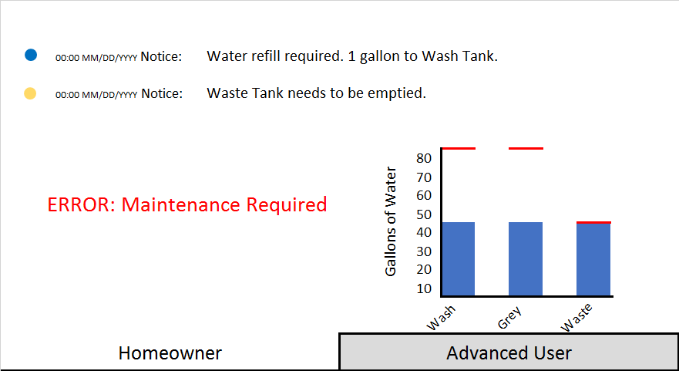

HomeownerView.png

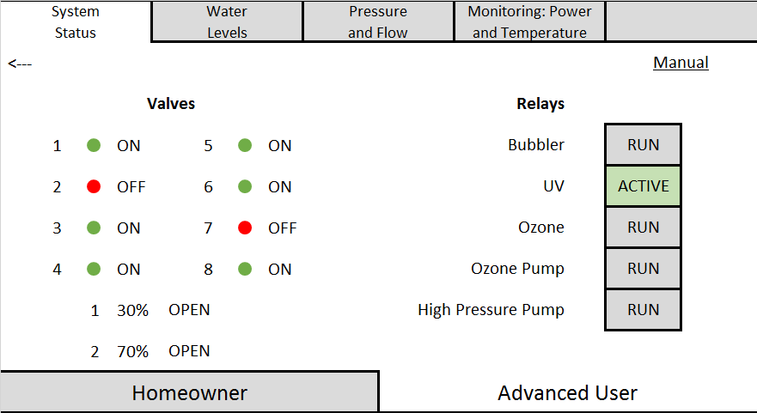

AdvancedUserView_SystemStatus.png

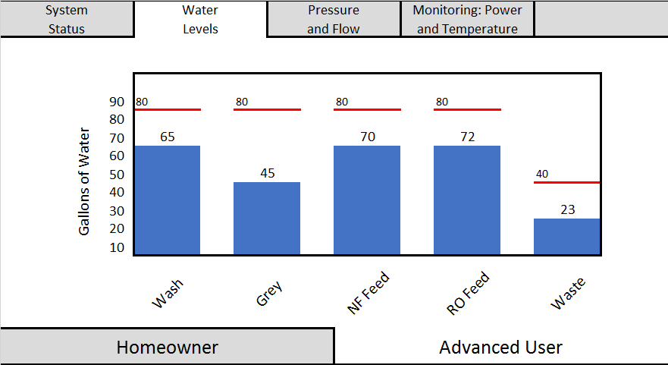

AdvancedUserView_WaterLevels.png

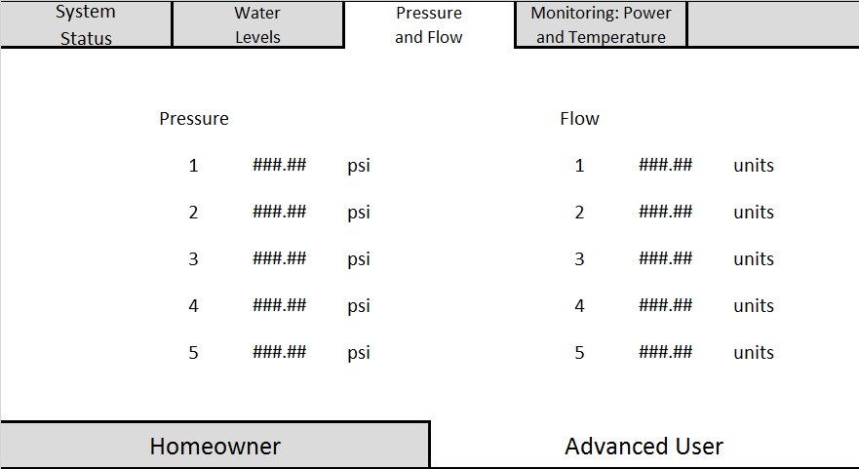

AdvancedUserView_PressureAndFlow.png

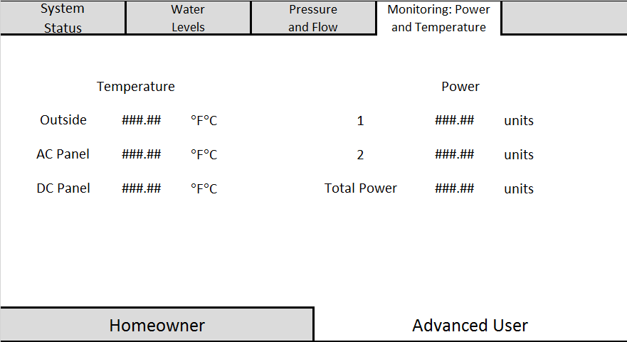

AdvancedUserView_Monitoring_PowerAndTemperature.png